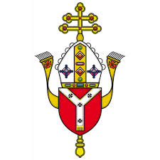
Westminster Diocesan secondary school questionnaire for parents and carers of All Saints Catholic School

To the Diocesan Inspection Team

My son/daughter is in Year …………………………………………………..

Please read the following statements and tick the answer which best fits what you think about the school. Please only tick one box per statement. If you cannot answer leave it blank.

Religious education | Agree strongly |  | Agree | Disagree | Disagree strongly
1. The school keeps me informed of what is taught in
religious education lessons
2. My son/daughter is making good progress in religious
education
3. There is regular and appropriate homework for my
son/daughter’s age and ability in religious education
4. Religious education is challenging and rigorous
The Catholic life of the school |  | Agree strongly | Agree | Disagree | Disagree strongly
5. The school offers a distinctively Catholic education
6. The school provides clear moral teaching
7. The school provides opportunities for spiritual
growth and development
8. There are regular sacramental celebrations of Mass
and Reconciliation
9. The school ensures that there are opportunities for
daily prayer
10. There are opportunities for my son/daughter to
serve others and support those in need
11. The school actively promotes strong partnership
with parents
12. There are strong links between the school and our
local parish(es)

13. If you want to explain any answers, or if there is anything else you want the inspection team
to know, please tell us here.

(Please use the back of this form to continue comments)

Please return this questionnaire in a sealed envelope to the school. Please mark the envelope

‘Confidential - for the attention of the Diocesan Inspection Team’. Thank you for filling in this questionnaire.

