ASCC Co-Curricular Life Guide

The Co-Curriculum
“The response must not just be about adding extra hours of study, but that children's broader needs must be taken into account. I think we need to think about the extra hours not only for learning, but for children to be together, to play, to engage in competitive sport, music, drama and activities because these are critical areas which have been missed in their development."
Sir Kevin Collins (BBC News) 2021

What is the purpose of a co-curriculum?

A co-curriculum complements learning in the academic curriculum to provide each student with a skill set that will support them into the future. A well-balanced combination of academic and co-curricular learning increases the willingness to take risk, develops social interaction, boosts confidence and enhances the development of leadership skills. These skills and opportunities are more important than ever!

What are the benefits?
- Pupils will learn new skills
- They will make new friends- never underestimate the importance of connecting to others and building networks
- They will keep a balance between their academic life and co-curricular life
- Improved academic performance: one might worry that participating in co-curricular activities will detract students from their schoolwork, but that is not the case. Active participation in an activity they are passionate about will improve their brain functioning. They will develop their concentration and time management skills.
- It will help students learn by doing something different from in a classroom: problem solving, reasoning, critical thinking, creative thinking, cultural understanding …etc.
- It is a proven way to stimulate creative thought, improve their social and organisational skills, develop their interests and talents, and offer them the chance to switch off and do something they really enjoy.
- Stress relief and relaxation: Working on homework, studying for exams, thinking about their future – these things can all seem overwhelming. Co-curricular activities provide learners with the opportunity to concentrate their efforts somewhere else.
- Co-curricular activities are an essential part of any good college application; it can show someone’s commitment, passion and leadership.

All Saints co-curricular offer
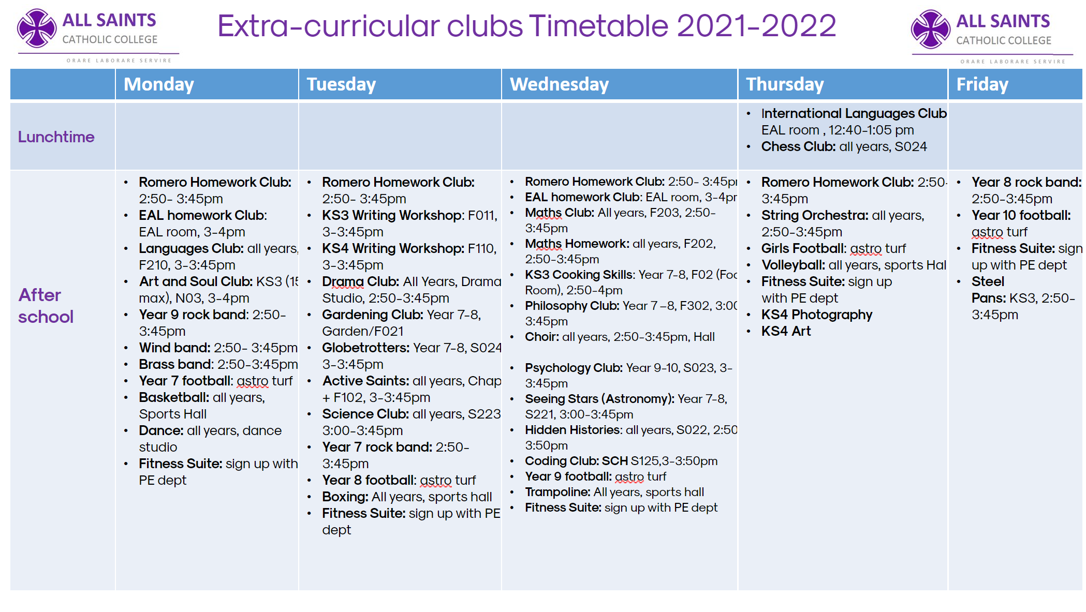

Links to Curriculum
Subject | Activity | Description
English | KS3 Writing Workshop  KS4 Writing Workshop | To give pupils a space in which to write creatively and imaginatively; To encourage budding writers to produce pieces of creative writing which we can put forward for competitions; To give pupils more one on one support with their writing skills; To play games and have fun with literacy in a more relaxed classroom environment.
 | EAL Homework club | To support students who are in the process of developing their English as an additional language
Maths | Maths Club | Puzzles, Games and Activities which develop mathematical curiosity
 | Chess Club | Develop problem solving Skills
Science | Seeing stars | Students will learn about the night sky and some of the science behind what we know about the Solar System, using practical work, modelling and theory.
 | Science Club | Individual hands on science experiments to enhance students' scientific thinking and enable them to relate the theory learning part of the curriculum
 | Gardening Club
RE | Active Saints | A program which allows students to develop in three areas; work, prayer and service.
 | Philosophy Club | To give students an introduction into philosophy's big questions
 | Schola | Liturgical choir to support Catholic ethos.
MFL | Languages Culture Club | A club where all are welcome to come and learn about various aspects of the culture of France and Spain. Aiming to develop cultural understanding and compare with their own countries, leading to better intercultural understanding.
 | EAL International languages Club | Students who have English as an additional language will take turn to teach their fellow classmates their own native language. To improve oracy, speaking in public, friendship making and cultural understanding
Humanities | Psychology Club | Learning about key psychology studies and how to plan and execute their own study.
 | Hidden histories | Looking at the hidden histories within broader topics. Concluding in a museum display project.
 | Globetrotters | Providing opportunities for pupils to explore parts of the world which are not actively covered in the curriculum and reinforce it. Students will be able to study social, economic and environmental aspects of these areas, with opportunities to delve into other subject areas (History, English, Art etc) to broaden their understanding.
Art and Design | Art and Soul club | Support in learning key art skills, experiment with different art media
 | Cooking Club | KS3 cooking skills support
ICT | Coding Club | KS3 curriculum support
Drama | Drama Club | Developing drama skills and have an opportunity to be a part of the Black History Performance. This is open to students who are interested in design/directing/performing.
PE | Year 7 football  Year 8 football  Year 9 football  Year 10 football  Girls football  Basketball (mixed)  Volleyball (mixed) | To give students the chance to train and play specific sports in a competitive setting. Learning specific skills related to playing in a squad as well as general physical conditioning to maintain good health and fitness goals.
 | Boxing | Outside coach to learn skills related to boxing, self-defense and health and fitness
 | Dance | Outside coach to teach specific skills as well as to maintain general good health and fitness life goals.
 | Trampoline | Develop core strength and discipline in a fun way. Maintain general good health and fitness life goals.
 | Fitness suite | Develop general good health and fitness life goals.
Music | Choir | Develop skills to sing pop tunes/show songs
 | Schola | Liturgical choir
 | Year 7 rock band  Year 8 rock band  Year 9 rock band  Wind band  Steel pans  String orchestra | The KS3 National Curriculum for music asks that pupils be taught to "play and perform confidently in a range of solo and ensemble contexts using their voice, playing instruments musically, fluently and with accuracy and expression". Running the extra-curricular ensembles that we run allow us to give pupils those kinds of performance opportunities.

Planned trips and curriculum links
Department | Trip | Link with curriculum
SEN | Life skills  Every Tuesdays | To support students with specific learning needs to deal with life requirements.
ASDAN College
Every Thursdays
PE | Ski trip to Italy  Date: 1-9th April | The ski trip is a fantastic opportunity for students to push themselves out of their comfort zone and try a new and challenging skill. The PE curriculum and extra-curricular club offering are designed to allow students time to engage with a range of different sports that they may have never experienced before. The ski trip is an extension of this offering and we hope students enjoy the challenge of learning the new skills required to ski confidently down the slopes of Bardonecchia .
EAL | London Bus Tour  Date: 13th Dec | Reward trip and also to develop their cultural understanding of London.
Food Technology | Bread making and Borough Market –Year 10  Date: 18th April 2022 | To attend the Bread school at borough market as part of the new AQA food preparation & Nutrition curriculum so as to gain an understanding on how bread is produced on a large scale for sale in the market. To take a tour of Borough market and learn alternative sources of buying fresh wide ranging food produce as opposed to supermarkets.
Science | Trip to Science Museum  Or Greenwich Observatory  Date : TBC
English | Shakespeare Play  The Merchant of Venice  Date: TBC February
Drama | Blood brothers Theatre trip  Date: 27th November | In GCSE Drama all students will need to demonstrate their knowledge and understanding of how drama and theatre is developed. This is through responding to live theatre. The students will be seeing a professional theatre company perform their chosen performance text 'Blood Brothers'.
Languages | French Institute (film)  Date: 25th November | Film was projected in French so students are exposed to the language and learn about the culture and develop both their Listening skills, build their vocabulary and their cultural understanding which are all part of the Languages curriculum.
Music | Schola Reward trip in Kingston  Date: 9th Dec | The schola choir is going to sing in St Agatha’s church, practicing having an audience but after that they will also be going to play bowling as a reward for Term 1.

